Task 1

In this report, we will compare the path-finding abilities of several graph search algorithms, Random Search, BFS, DFS, Greedy Search and A Star. In this problem we are considering the 2D grid as a graph with each grid cell being one node in the graph. Each node is connected to at most four other nodes (Up, Down, Left and Right). The number of neighbors a node has depends on the location of the node and whether it has been places by an obstacle or not.

To find a path from start to goal, each search algorithm starts with the start node and tries to explore the graph one node at a time. Once the goal node is discovered, the algorithm will back trace to the start node and form the path from start to goal.

Task 1-a

In this task, we are applying the Search Algorithms to the following map.

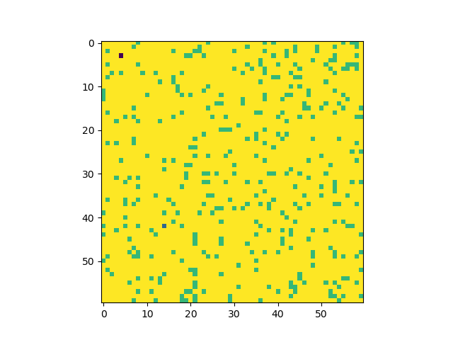

Random Search: Random Search is a very simple algorithm that would explore the graph randomly. From every discovered node, the algorithm will randomly select a neighbor and continue the exploration until we either reach the goal or reach a node that has no neighbors. In our implementation, we have assumed that the random path cannot cross itself. In our experience in most cases, this algorithms fails to properly explore the graph and terminates pre-maturely.

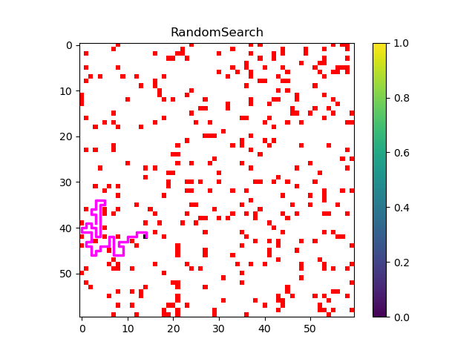

BFS (Breadth First Search): BFS is an exhaustive search algorithm that explores the graph one node at a time. In this algorithm, for every node that is visited by the algorithm all its neighbors are added to a Queue. The queue data-structure forces BFS to explore the graph around the starting point at an equal paste. This can be seen in the following figure :

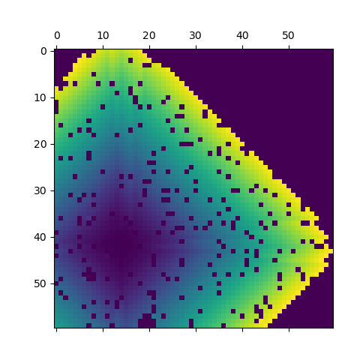

If we assign an index to every node that is discovered by BFS, this figure is a visualization of these indices. As we can see, as we get further from the start position (placed in the dark spot in the lower left corner of the image) the indices increase. The path discovered by BFS is shown in the following figure :

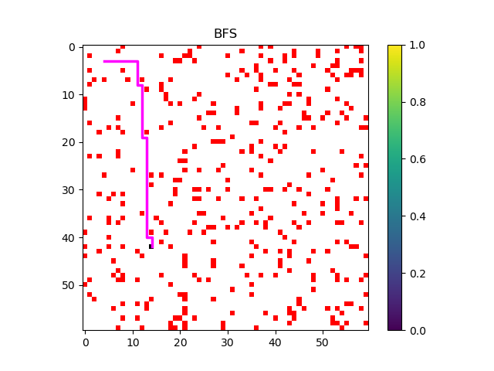

The length of this path is 50 nodes.

Due to the construction of BFS, this algorithm is guaranteed to find the shortest path between start and end.

DFS (Depth First Search): DFS is similar algorithm to BFS but utilizes a stack rather than a queue for exploring the graph. Since a stack has the property of first in last out, the algorithm tends to explore the graph by prioritizing the most recent discovered nodes. The difference between BFS and DFS can be seem in the following figure, which suggests that DFS tends to pick some path within the graph explore its depth as much as possible.

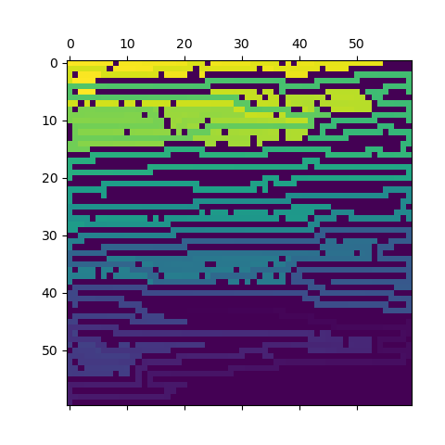

Because of this the path found by DFS from start to goal tends to be rather long. This path can be seen in the following figure:

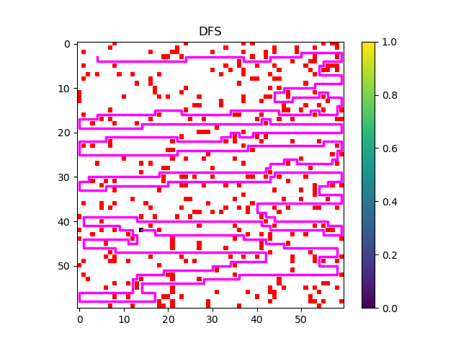

The length of this path is 900 nodes.

Greedy Search (Greedy Best First Search) : Unlike the previous three algorithm, this algorithm assumes that the position of goal is known and we want to find the best path from start to goal. In this algorithm we will utilize a distance function that can measure the distance from each discovered node to the goal. Here, when a node is discovered, the path to the goal continues with the neighboring node that has the shortest distance to the goal. A main disadvantage of this algorithm is that in some cases the algorithm might get stuck and fail to reach the goal. This usually a drawback of the greedy algorithms.
We will analyze the Greedy Search algorithm using to distance functions, Manhattan distance and Euclidean Distance.

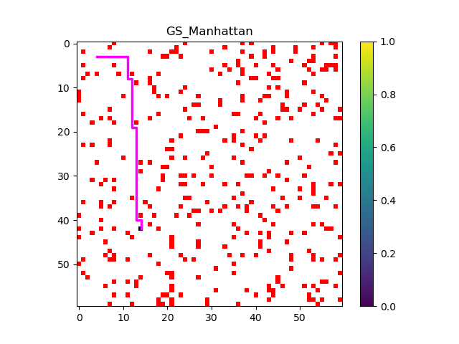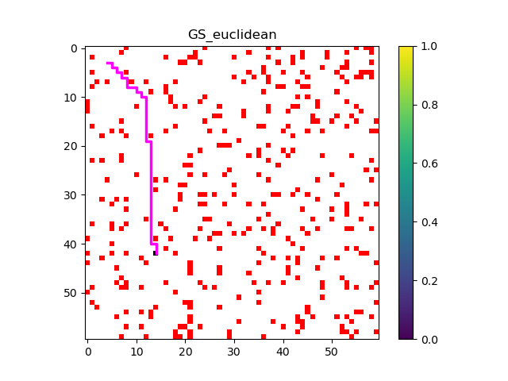

Here we can see that the Manhattan distance tries to avoid moves. The length of the path found by both distances is 50 nodes. This is also equal to the length of the path discovered by BFS.

It should be mentioned that because of or choice of neighboring functions and now allowing true diagonal moves, the diagonal solution found via the Euclidean distances has the same cost as the solution found by the Manhattan distance.

A* Search : The final search algorithm is the A* search which explores the graph to find the goal by avoiding exploration in directions that have a high cost (getting away from the goal). To enable this for every discovered node (say n) we calculate the following:

G(n) : Cost so far to reach n, which essentially the length of the shortest path from start to the node n.
H(n) : The heuristic distance from node n to the goal, which is calculated by a distance function
F(n) : Which is the estimated cost of a path from start to goal which goes through node n.

We can visualize these functions on this problem to see how their values change as the algorithm explores the graph.

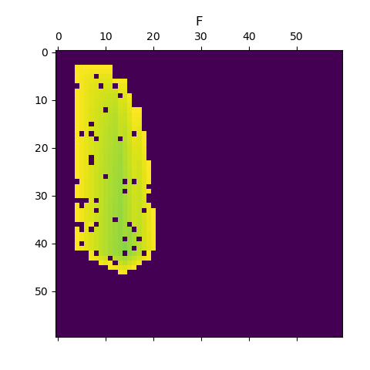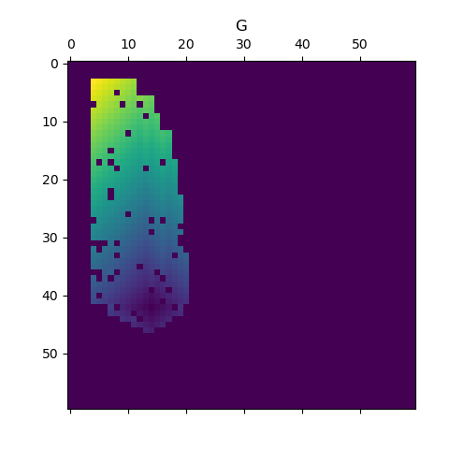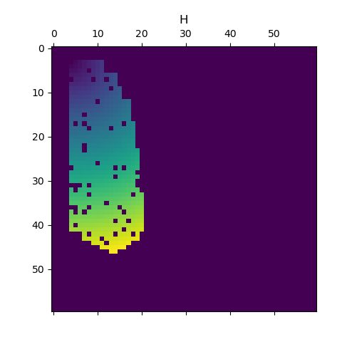

These are the F,G,H functions associated with the Euclidean Distance and we can see that unlike BFS and DFS, the exploration of the graph is only done towards the goal and the algorithm has avoided the directions that go further from the goal. By further examining the F function, we notice that there a green area (lower value) connecting the start to the goal. Our understanding is that the optimal path should exist within this green area.

Now by looking at the shortest path connecting the start to goal for both distances Manhattan and Euclidean. We can first confirm that the shortest path was found within the green areas of the previous plot and see they show a similar behavior to the Greedy Search.

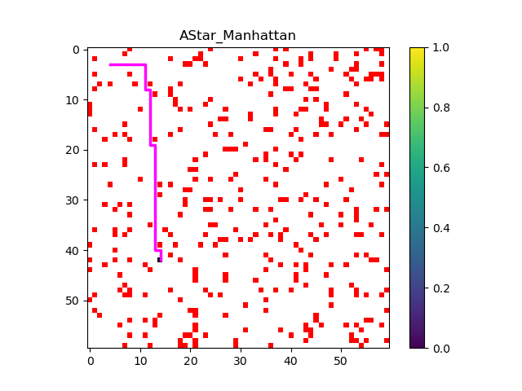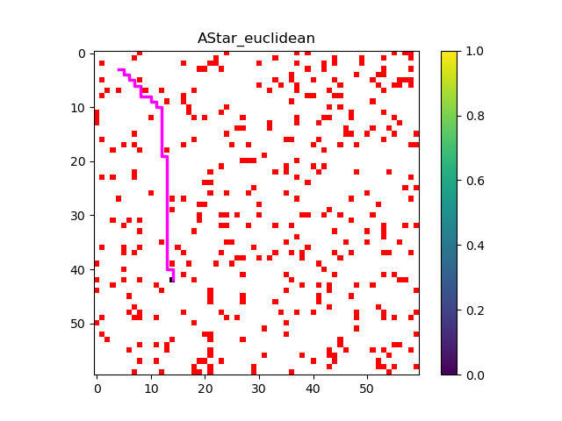

The length of the path in both cases is 50 nodes.

Task 1-b

With the obstacle (rotated-H) in the middle of the grid we want to see how different algorithms find a path from start to goal.

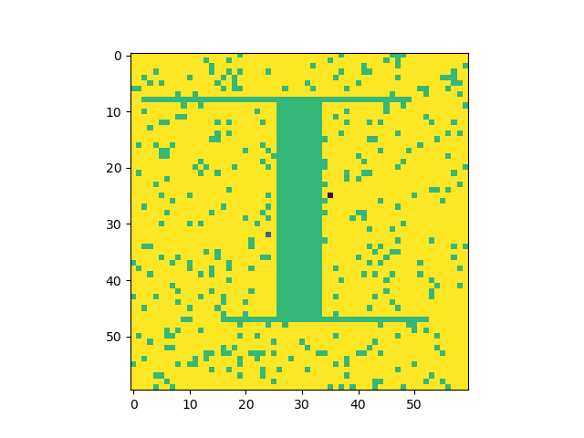

Random Search : As expected (Task 1-a), Random Search fails find a path to the goal.

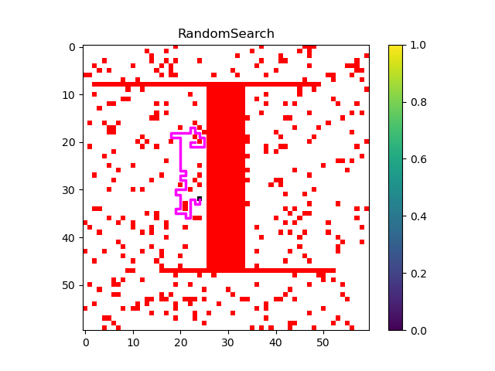

BFS: With the obstacle in place, the following figure show how exhaustively the BFS algorithm has explored the graph to find the path between start and goal. The length of this path is 111 nodes.

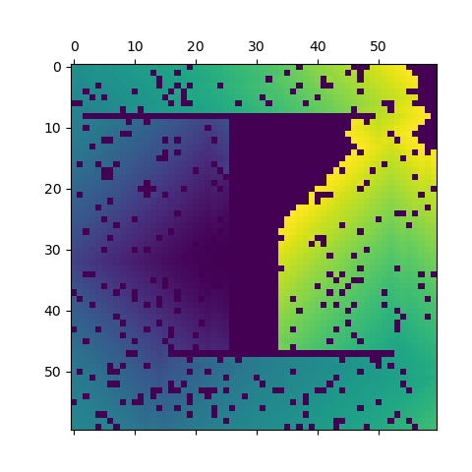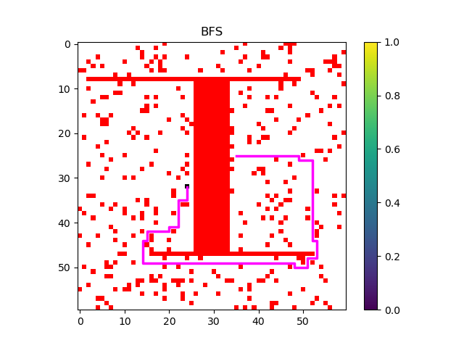

DFS: The difference between BFS and DFS can be very well understood in this example. Even though the length of the path found by DFS is much longer than BFS (333 nodes vs 111 nodes). We can see that DFS was able to find a path between start and end. Since there are many path in the graph that connect one side of the obstacle to the other, DFS will end up exploring the other side of the obstacle (where the goal is located) much faster than the BFS algorithm.
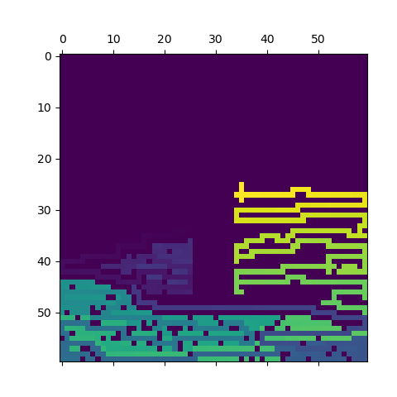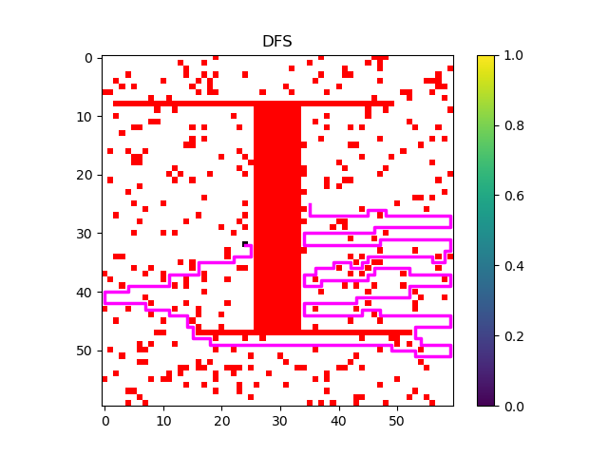

Greedy Search: In this example Greedy Search fails to find a path between the start and the goal. This because simply exploring the graph by choosing the node closest to the goal will always move the path toward the obstacle since start and goal are placed on different sides of the obstacle.

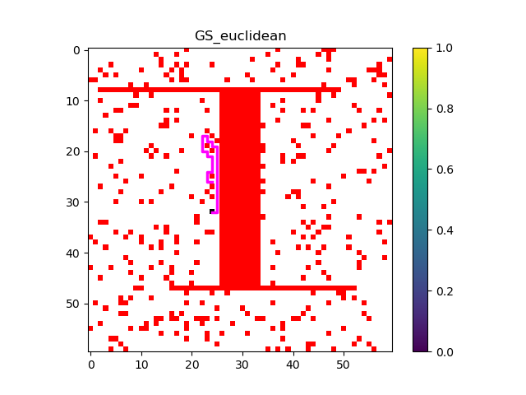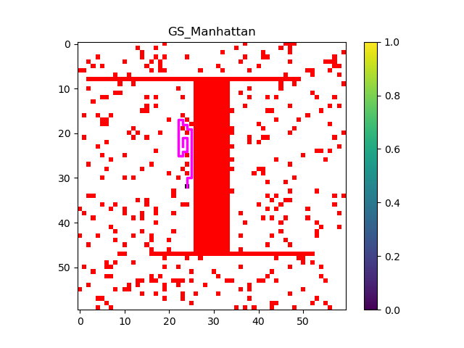

A* Search: In this problem A* Search algorithm using both Mahattan and Euclidean distances find a path of 111 nodes (which is equal to the BFS)

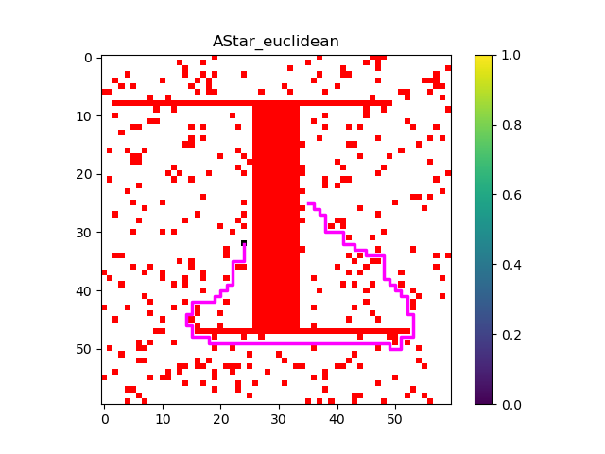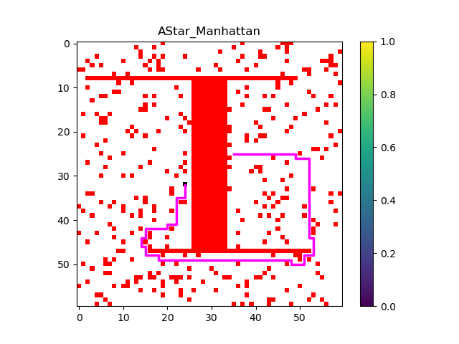

We can see how this method search for the path in the following figures. The number of node discovered by this algorithm was 2217.

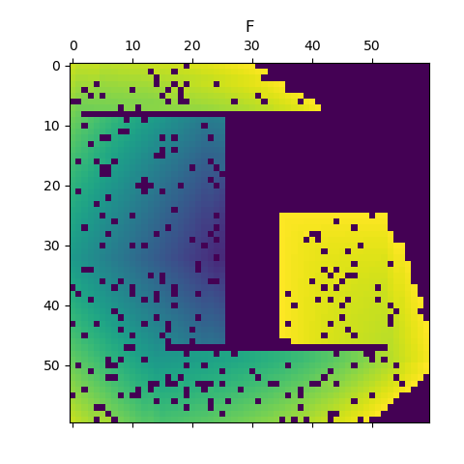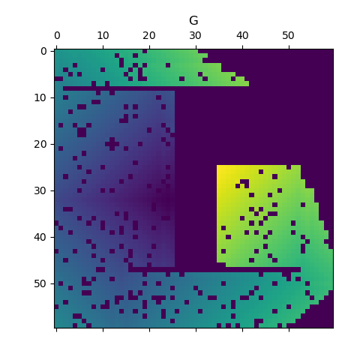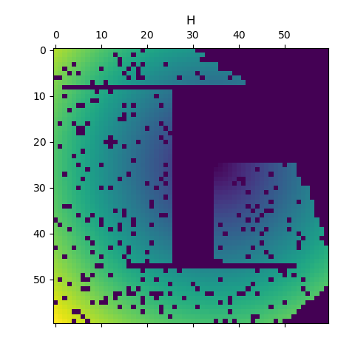

Heuristic Expansion: Based on the above, we use the following heuristic to reduce the number of nodes discovered by the A* Search algorithm. If the Y of the start position is less than half of the grid height, we will expand only (up, left) until we reach the top of the grid and after that we will expand (up, down, left, right). If the Y of the start position is more than half of the grid height, we will expand only (down, left) until we reach the bottom of the grid and after that we will expand (up, down, left, right).

The effect of this heuristic can be seen in the figures below:

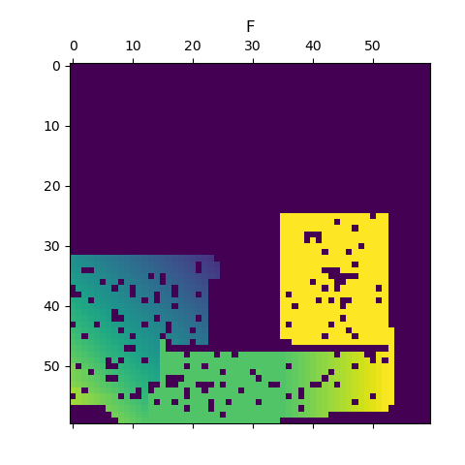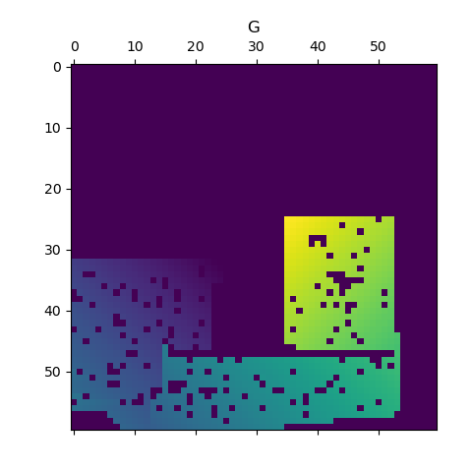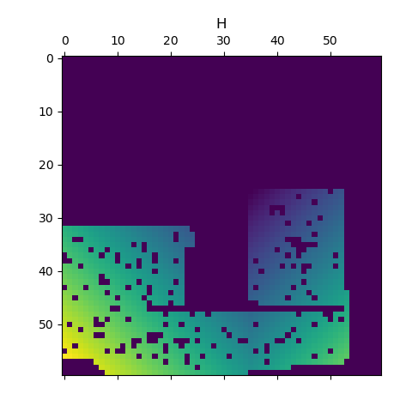

As it can be seen, the algorithm has explored a significantly smaller number of nodes in the graph (1214 nodes). Unfortunately, a side effect of this heuristic is observed in the size of the of the discovered path with 133 nodes :

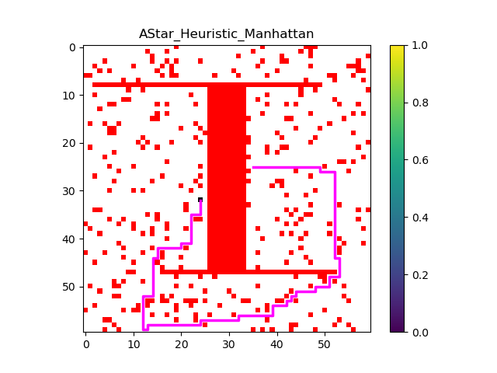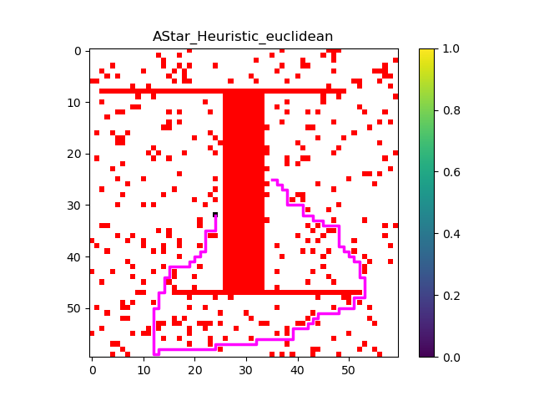

Statistical Analysis

The results below are average over 20 different runs.

Algorithm | Path Length | Nodes Expanded
BFS | 98.95 | 2433.8
DFS | 529.35 | 1233.75
A* Euclidean | 98.95 | 1628.2
A* Manhattan | 98.95 | 1701.05
A* H Euclidean | 104.15 | 730.85
A* H Manhattan | 102.15 | 836.0

